1. Write and execute a C program to read the age of a candidate and determine whether it is eligible for casting his/her own vote. The eligibility for casting a vote is 18 years

#include <stdio.h>

main()

{

Int voter_age;

printf("Enter the age of the candidate : ");

scanf("%d",&voter_age);

if (voter_age<18)

{

printf("You are not eligible to caste your vote \n");

}

else

printf("You are eligible for casting your vote \n");

}

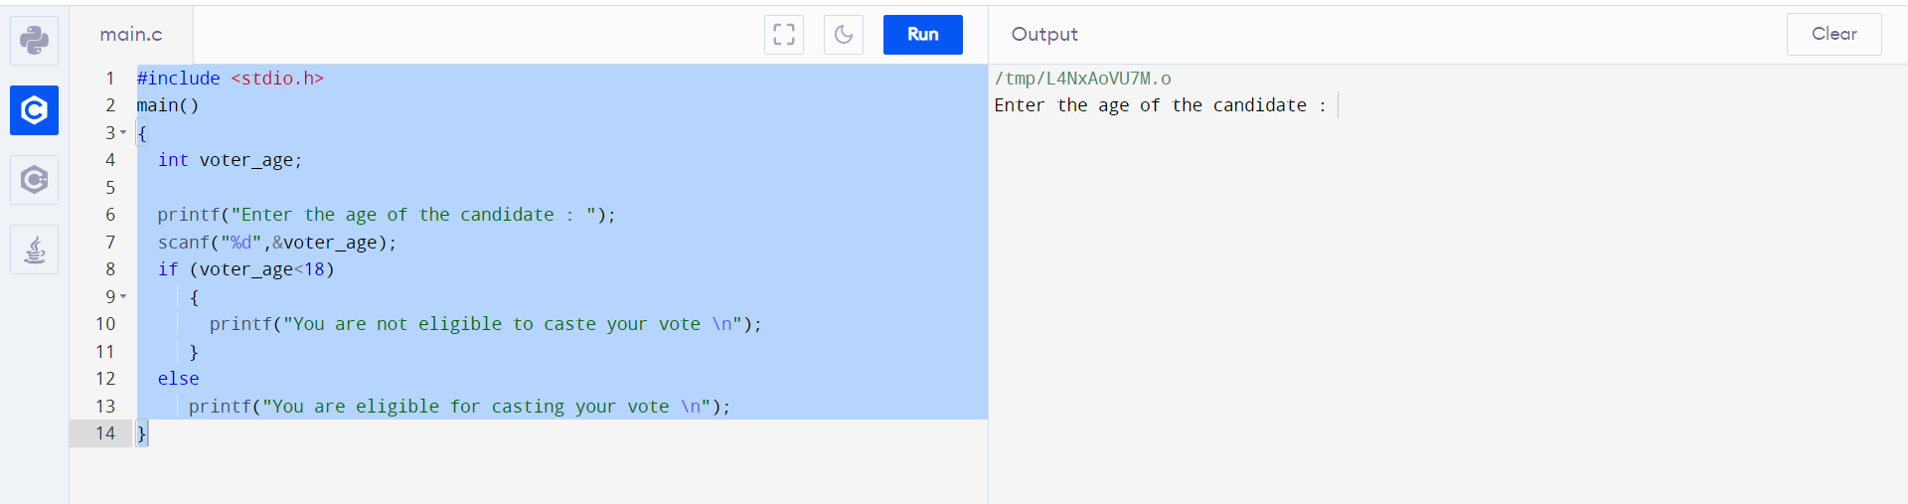

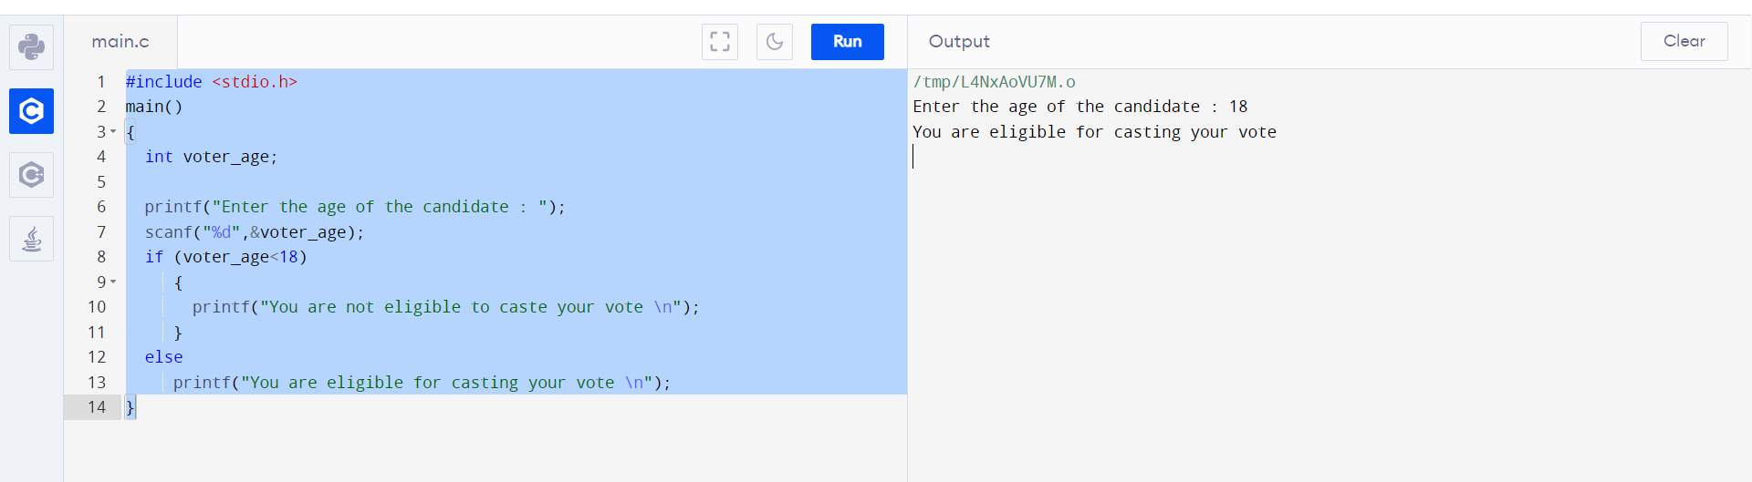

1. Write and execute a C program to find whether a given year is a leap year or not.

#include <stdio.h>

main()

{

int year;

printf("Enter a year :");

scanf("%d", &year);

if ((year % 400) == 0)

printf("%d is a leap year \n", year);

else if ((year % 100) == 0)

printf("%d is a not leap year \n", year);

else if ((year % 4) == 0)

printf("%d is a leap year \n", year);

else

printf("%d is not a leap year \n", year);

}

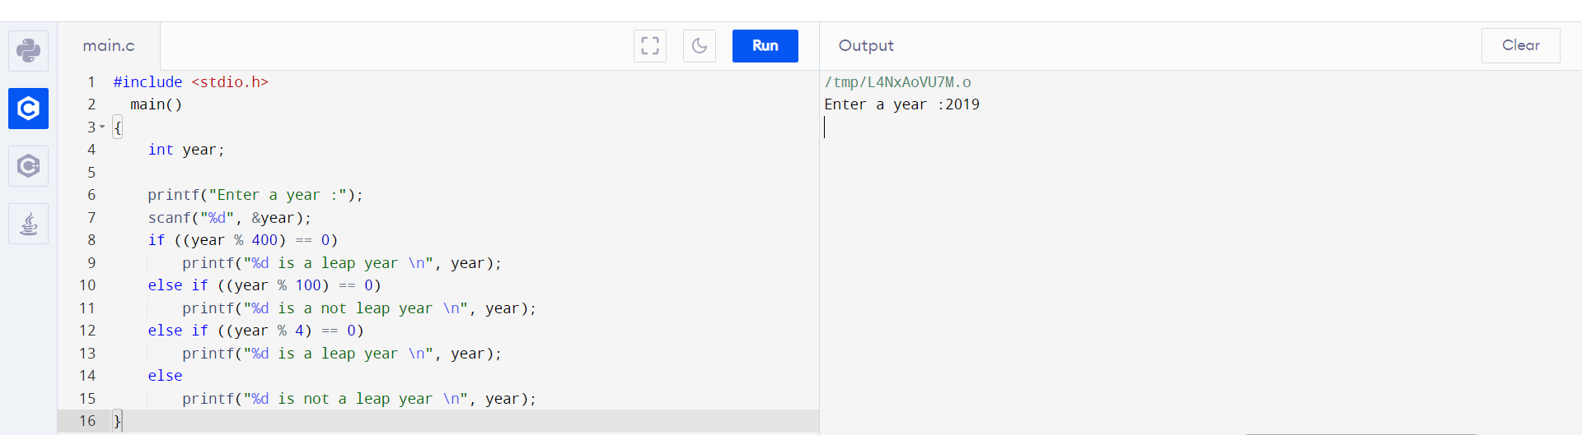

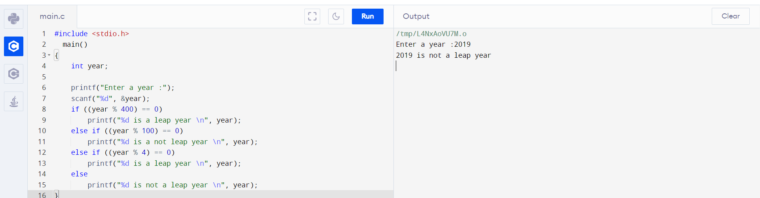

1. Write and execute a C program to find the largest of 5 given integers.

#include<stdio.h>

int main()

{

inta,b,c,d,e;

printf("ENTER THE FIVE NUMBERS \n");

scanf("%d %d %d %d %d",&a,&b,&c,&d,&e);

if(a>b && a>c && a>d && a>e)

printf("%d is largest", a);

else

if(b>c && b>d && b>e)

printf("%d is largest", b);

else

if(c>d && c>e)

printf("%d is largest", c);

else

if(d>e)

printf("%d is largest", d);

else

printf("%d is largest", e);

return 0;

}

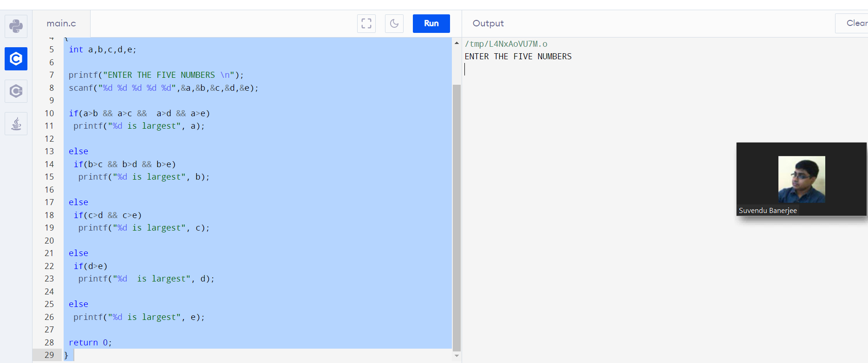

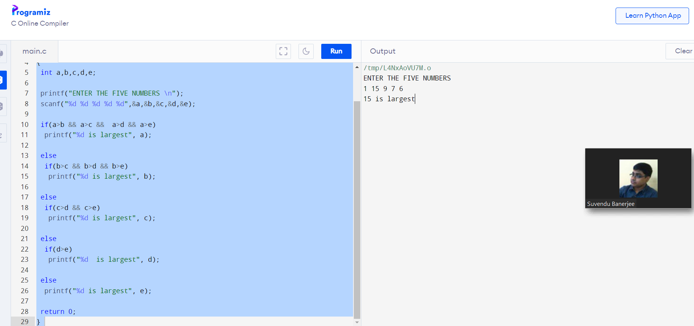

1. Write and execute a C program to read the value of an integer m, and display the value ‘1’ when m is larger than 0, ‘0’ when m is 0 and ‘-1’ when m is lesser than 0

#include <stdio.h>

void main()

{

intm,n;

printf("Input the value of m :");

scanf("%d",&m);

if(m>0)

{

printf("The value of m = +1 \n");

}

else

if(m==0)

{

printf("The value of m = 0 \n");

}

else

{

printf("The value of m = -1 \n");

}

}

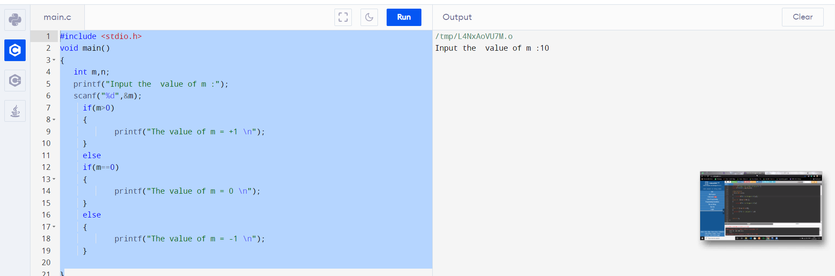

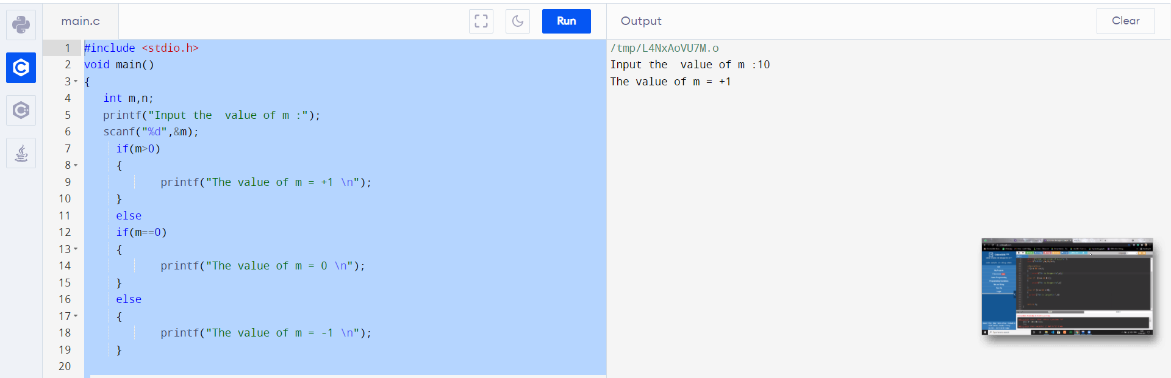

1. Write and execute a C program to accept a coordinate point in a XY coordinate system and determine in which quadrant the coordinate point lies.

#include <stdio.h>

void main()

{

int cord1,cord2;

printf("Input the values for X and Y coordinates : ");

scanf("%d %d",&cord1,&cord2);

if( cord1 > 0 && cord2 > 0)

printf("The coordinate point (%d , %d) lies in the First quandrant \n",cord1,cord2);

else if( cord1 < 0 && cord2 > 0)

printf("The coordinate point (%d , %d) lies in the Second quandrant \n",cord1,cord2);

else if( cord1 < 0 && cord2 < 0)

printf("The coordinate point (%d , %d) lies in the Third quandrant \n",cord1,cord2);

else if( cord1 > 0 && cord2 < 0)

printf("The coordinate point (%d , %d) lies in the Fourth quandrant \n",cord1,cord2);

}

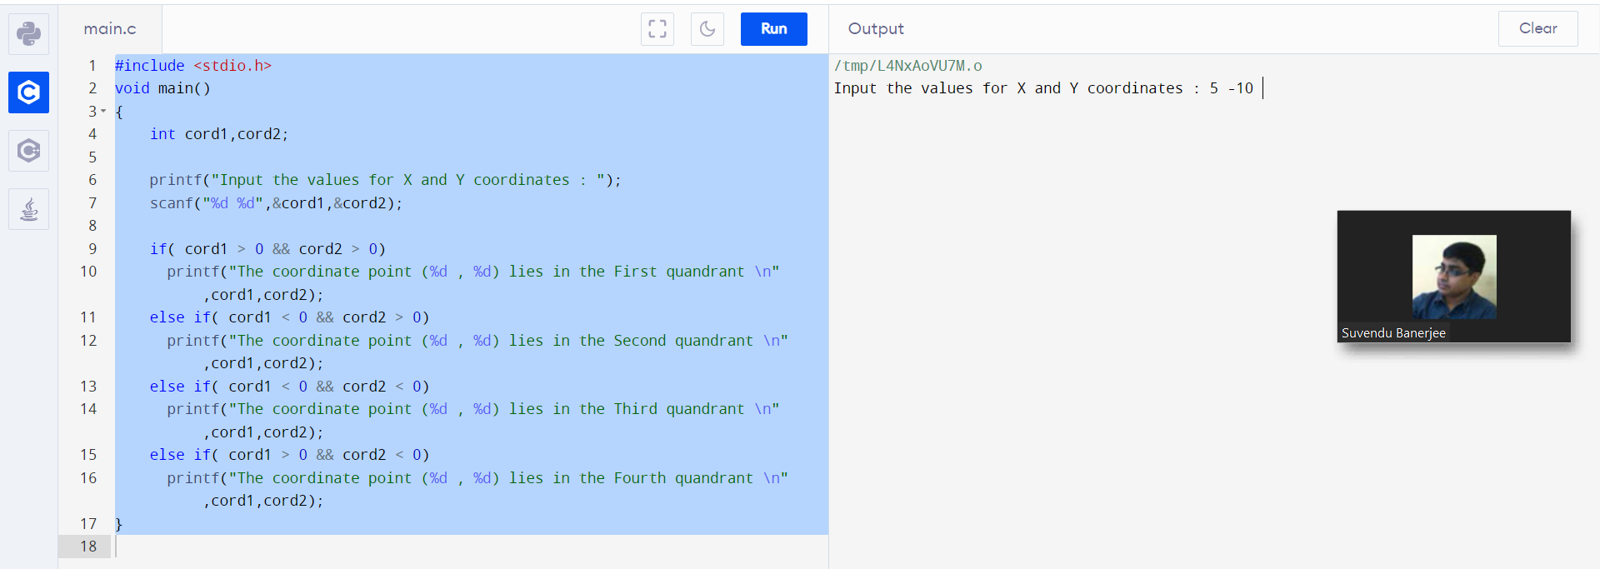

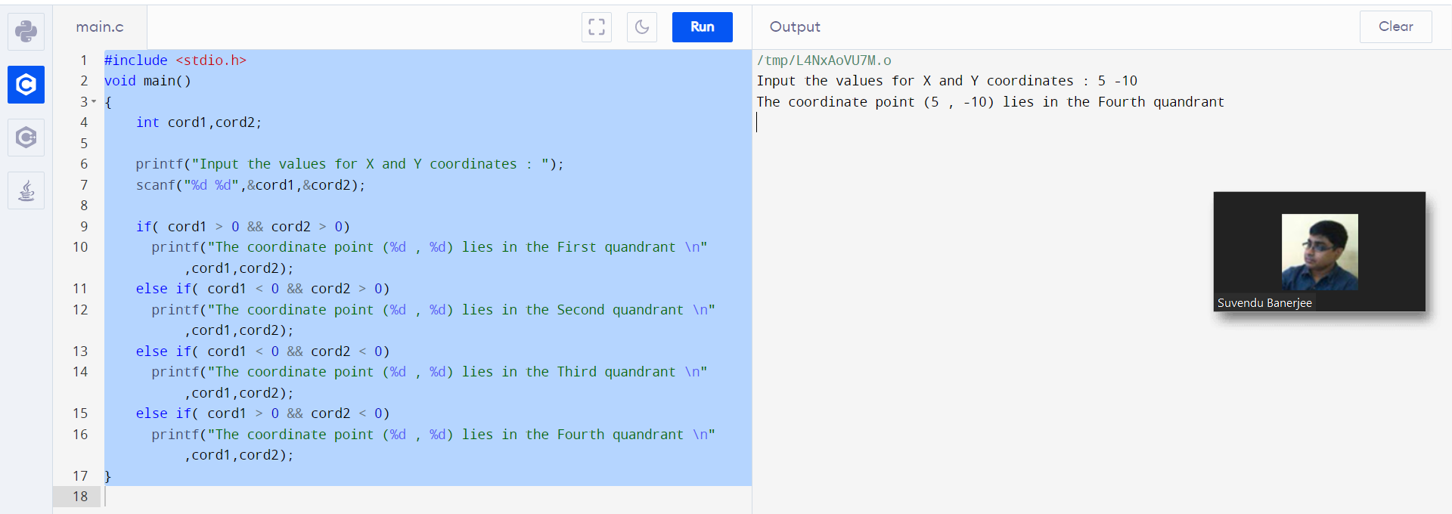

1. Write and execute a C program to calculate the root of a Quadratic Equation

#include <stdio.h>

#include <math.h>

int main()

{

int a, b, c, d;

double root1, root2;

printf("Enter a, b and c where a*x*x + b*x + c = 0\n");

scanf("%d %d %d", &a, &b, &c);

d = b*b - 4*a*c;

if (d < 0)

{

printf("First root = %.2lf + i%.2lf\n", -b/(double)(2*a), sqrt(-d)/(2*a));

printf("Second root = %.2lf - i%.2lf\n", -b/(double)(2*a), sqrt(-d)/(2*a));

}

else { // real roots

root1 = (-b + sqrt(d))/(2*a);

root2 = (-b - sqrt(d))/(2*a);

printf("First root = %.2lf\n", root1);

printf("Second root = %.2lf\n", root2);

}

return 0;

}

